Aldabra Tropicbird monitoring

Fernando Cagua

10 June 2016

# Methods

## Data collection

Feeds from protocol

## Data analysis

### Breeding seasonality

To determine the breeding periodicity (rhythmic patterns) of the focal species we used a wavelet analysis of the number of new nests per species. Akin to a Fourier transform, the wavelet decomposition identifies the dominant cycles in the time series. However, by quantifying the power of different periods changes trough time, it also allows to detect temporal changes on the seasonality. We then evaluated the significance of these results by comparing the power of the empirical time series to that of 99 randomisations.

Although the wavelet analysis provides an indication of the duration of the periods, it does not provide information on their timing. To do assess when the periods of high and low nesting activity occur, we used a series of generalised additive mixed effect models (GAMM) in which the response variable was, again, the number of new nests established in each species. In these models, we included *date* and *month* as smooth terms. Date was included to detect long term trends in nesting establishment, while month was included to account for the non-linear variation across the year. In addition, to account for differences on survey effort the number of surveys per month was also included as a linear predictor. Finally, we accounted for potential variation in breeding across years we included it as a random effect. Errors in all models were Poisson-distributed.

Furthermore, we expect potential increases in nest establishment to be consistent by an increase on nests that were observed to be occupied by an egg or small chicks not yet feathered. Therefore, we also constructed a series of GAMMs with the same predictors that our original models for these two additional dependent variables.

### Breeding success

To determine whether a nest was successful of not, we determined the stage at which it was last observed. If a nest was observed to be occupied by an egg or a partially feathered chick and it was later observed empty or with signs of depredation, we assumed nesting was unsuccessful. If, conversely, a nest was observed to be occupied by a fully feathered chick and in a posterior visit the nest was found to be empty and without signs of depredation, we assumed that nesting was successful and therefore fledgling was likely to occur.

We then were interested on inspecting the temporal trends on nesting success and the factors that influence it for each of the focal species. We therefore constructed a series of GAMMs with a binomial error structure to model the probability that a) nesting was successful, b) nesting failed at the egg stage, or c) nesting failed at a chick stage. Temporal trends were investigated by including *date* as a smooth term. As additional coovariates in this model we included the islet's distance to Piccard (the closest major island in Aldabra), the islet's size, and whether there has been evidence of rat presence at any point during the sampling period.

# Results

Surveys were consistently performed between 2009-02-06 and 2016-11-04. In total 202 surveys were performed at a mean frequency of 2.3 ± 0.8 (mean ± standard deviation) per month. During these trips we detected a total of 673 individual nests for *P. rubricauda* and 333 for *P. lepturus*.

### Breeding seasonality

The wavelet analysis indicated an overall significant seasonality on the establishment of new nests by *P. rubricauda* but not for *P. lepturus*. For *P. rubricauda* the dominant period for nesting was approximately twelve months. Nevertheless the intensity of this yearly cycle has been damped to the point to which there was no significant seasonality since late 2014.

The results of the wavelet analysis were strongly supported by the GAMMs, which indicated a significant effect of *month* on the number of new nests established by *P. rubricauda* ($p=<0.001$), but not by *P. lepturus* ($p=0.82$). Similarly, we found a significant effect of *month* on the number of nest occupied by downy chicks or eggs of *P. rubricauda* ( $p<0.001$ in both cases) but not on those of *P. lepturus* ( $p=0.1$ and $p=0.54$ respectively).

In addition, although there was no evidence that number of nests established by *P. lepturus* changed over time, we found a significant decreases on the number of new nests established by *P. rubricauda* ($p=0.03$)

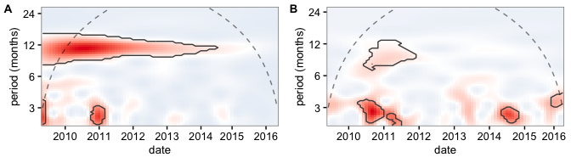

***Figure 1:*** *Wavelet decomposition of the number of new nests established by P. rubricauda(A) and P. lepturus (B) for the study period. The red colour indicates a higher power, and the dashed lines indicate the cone of influence, above which results should not be considered. The black contours indicate the regions in which periodicity was significantly different from the random expectation at the 0.05 level.*

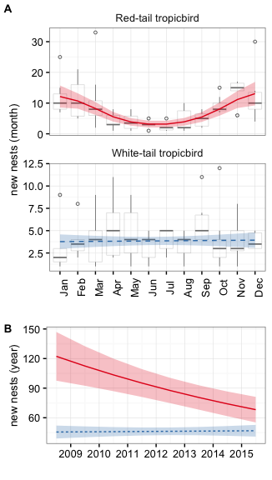

***Figure 2:*** *Number of new nests established by P. rubricauda (red) and P. lepturus (blue). Lines and the surrounding shaded area represent the mean number of nests and the correspondingstandard error of the modelled number of nests in (A) a monthly, and (B) a yearly basis. Boxplots show the number of observed data and the lines the modeled output. All boxes cover the 25th–75th percentiles, the middle line marks the median, and the maximum length of the whiskers is 1.5 times the interquartile range. Points outside this range show up as outliers. Solid lines indicate a significant relationsip at a 0.05 confidence level.*

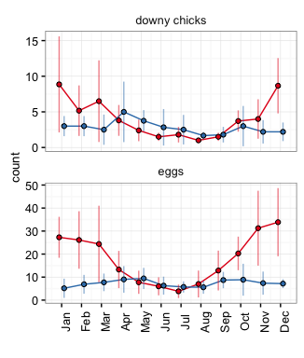

***Figure 3:*** *Mean number of observed downy chicks and eggs per month for P. rubricauda (red) and P. lepturus (blue). Vertical bars represent standard deviation of the observed values.*

### Breeding success

Overall, we were able to determine the outcome for 97% of the nests encountered. In average 14% of nests were successful, most of the nest failing at before the egg hatched (63).

Although the overall proportions of nesting success were very similar for both species, they are markedly different over time. While the probability that a *P.lepturus* nest is successful does not show evidence of change over time ($p=0.18$), that of *P. rubricauda* shows a dramatic reduction ($p<0.001$). Parallel to this decrease, we detected an significant increase on the proportion of *P. rubricauda* nests that fail before the egg hatches ($p=<0.001$).

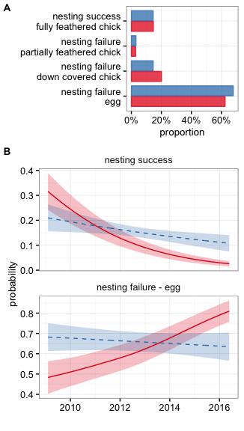

***Figure 4:*** *Nesting success for P. rubricauda (red) and P. lepturus (blue). (A) the overall proportion of stages for individual nests. (B) the modelled proabability of nesting success and failure (at the egg stage) over time. Solid lines indicate a significant effect at the 0.05 level.*

# Discussion

XXX

Consistent with Prys-Jones and Peet (1980) we found differing regimes for *P. rubricauda* and *P.lepturis*. While *P. rubricauda* breeds with a marked periodicity, *P.lepturis* does not. One difference, however, while Prys-Jones and Peet (1980) identified the lower peak of season to be August-September, our data supports a trough slightly earlier in June-July. The possible change in the breeding phenology of *P. rubricauda* might be related weather or resource conditions but a longer data set might be desirable to explore this relationship.

# References

Prys-Jones, R. P., and C. Peet. 1980. “Breeding periodicity, nesting success and nest site selection among red-tailed tropicbirds Phaethon rubricauda and white-tailed tropicbirds P. lepturus on Aldabra Atoll.” *Ibis* 122 (1): 76–81. doi:[10.1111/j.1474-919X.1980.tb00873.x](https://doi.org/10.1111/j.1474-919X.1980.tb00873.x).